PROFILE
Name | Dr. S. SELVAKUMAR | 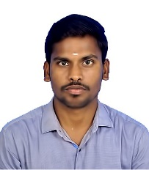
Qualification | M. Sc. (Ag.,), Ph. D.,
Designation | Assistant Professor
Department | Agronomy
Date of Joining | 16.03.2026
Total Teaching Experience | Nil.
NOTABLE ACHIEVEMENTS
Awards/Medals Received | 03
No. of Research/ Review Articles Published | 07
No. of Popular article Published | 03
No. of Book Chapters Published | 07
No. of Books Published | -
No. of Workshops/ Seminars/ Conferences/ Symposium Attended | 16
Patents Granted / Published | -

