PROFILE
Name | Er. D. Dhivya | 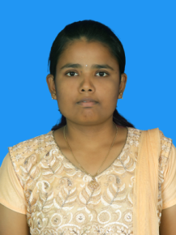
Qualification | M.E in Irrigation Water Management
Designation | Assistant Professor of Agriculture Engineering
Department | Agricultural Engineering
Date of Joining | 02/26/2024
Total Teaching Experience | 11 months
NOTABLE ACHIEVEMENTS
Awards/Medals Received | 03
No. of Research Articles Published | -
No. of Popular article Published | -
No. of Book Chapters Published | 01
No. of Books Published | -
No. of Workshops/ Seminars/ Conferences/ Symposium Attended | 10
Patents Granted / Published | -

